# Instructions for using the Matlab program for the study of calves

1. Download file “1_Calves.zip” into a folder on your computer and extract it;
2. Open Matlab SW;
3. Go to the folder with extracted files (folder have to contain CalvesIR.m, polygonxi.mat, polygonyi.mat, videoinput.avi);
4. Double click the file CalvesIR.m;
5. Click “Run”, Matlab SW starts to analyse the video file;
6. The output will be file videooutput.avi;

# Instructions for using the Matlab program for the study of dogs

Download file “5_Dogs.zip” into a folder on your computer and extract it;

## Step 1:

1. Create a folder on your computer and copy file dogs_script.m and two input files: Gofi 17042018_utek_108.mp4 and Gofi 17042018_utek_108.gpx;
2. Double click to open file dogs_script.m, SW Matlab should be opened (Matlab R2018b);
3. Set up the number of processed files (line 5), in our case, numberOfFiles = 1;
4. Click “Run” and wait for the pop-up window with the first frame of the proceeding video;
5. Select the region of interest. Keep the left mouse button and drop the rectangle. The rectangle should take a part of the dog´s head and the space before the dog but not the head-up display (e.g. compass, speed etc.) If needed, you can change the size of the rectangle or its position;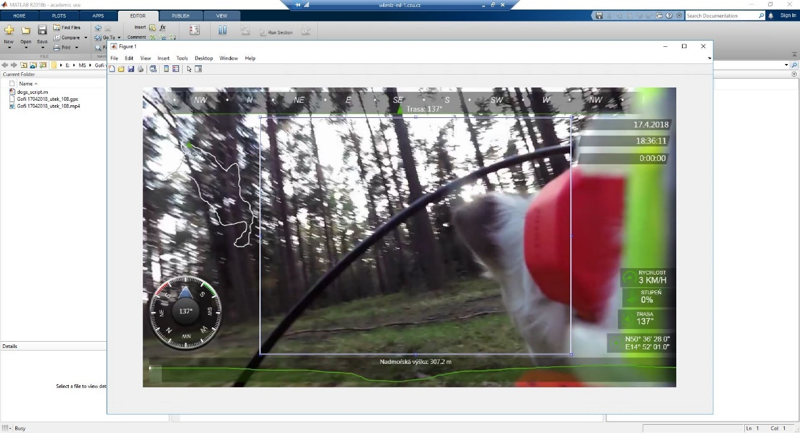
6. Double-click inside the rectangle; Matlab starts processing the video record. (Note: You can process more video recordings at once. In this case, Matlab, after double-click, will present the following pop-up window. After the last picture, Matlab starts processing.);

## Step 2:

1. In the Step 1 the Matlab SW created two new files: Gofi 17042018_utek_108_audio.mat and Gofi 17042018_utek_108_video.mat;
2. Create a new folder on your computer and copy files: dogs_analysis.m and two new files created in Step 1;
3. In Matlab, open the folder containing these three files;
4. Double-click the file dogs_analysis.m and click “Run”;
5. The pop-up window will be opened, and you can see a graph with audio and video output;
6. Mark all pauses in the movement; keep the button "shift" and mark all pauses by the left mouse button;

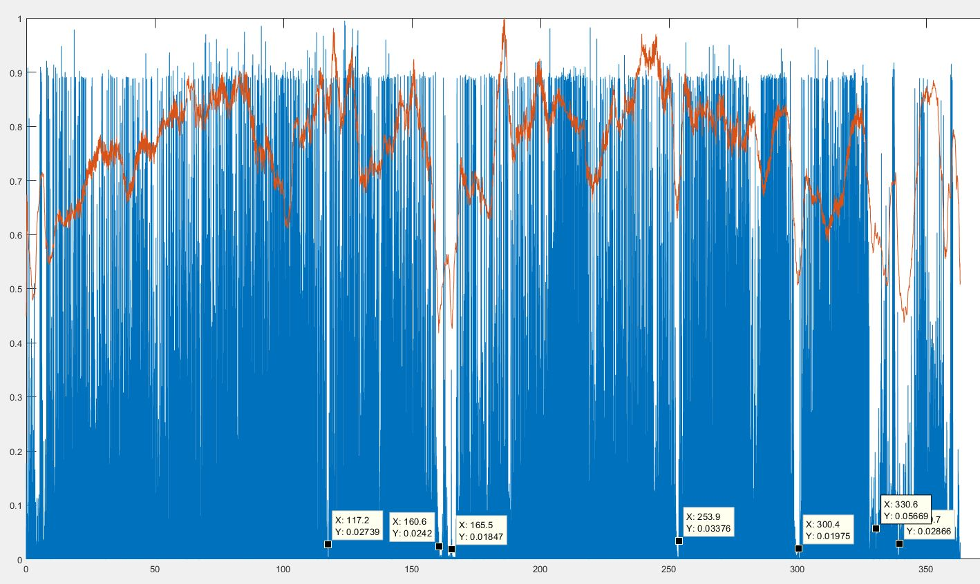

1. After marking pauses, click the right button, choose the option “Export Cursor Data to Workspace, " and confirm “OK”;
2. Close pop-up window with graph. (Note: You can process more files at once.);

**Step 3:**

1. In Step 2 the Matlab SW created a new file: Gofi 17042018_utek_108_cut.mat;
2. Copy the file dogs_video.m to the new folder and copy three output files (created in Step 1 and 2) and two input files;
3. In Matlab, open the folder containing these five files;
4. Double-click the file dogs_video.m;
5. Set up the path to the folder “cisla” in line 3;
6. Set up the length (in sec.) of the video cut window in line 48, and click “Run”;